
a
Company
Logotype

Cone Beam Computed Tomography- Report



Porur Dental X-rays & CBCT

Patient Name : Mr. Devadoss | Date of Report : 22.04.2024
Age/ Gender : 60 years/ Male | Region of Interest : CBCT Full Skull
Referring doctor: Dr. N. Hemachandar | Indication : Implant assessment
Clinical Notes: Nil
PATIENT INFORMATION

CBCT- Full Skull provided
CBCT – IMAGE DETAILS

RADIOGRAPHIC INTERPRETATION

- Partially edentulous maxillary and mandibular alveolar ridge with missing teeth: 11, 12, 13, 17, 18, 21, 22, 23, 26, 27, 28, 37, 45, 46, 47.
- Horizontally placed tooth: 48.
- Hyperdense crown structure in relation to 31, 32, 33, 34, 41, 42, 43.
- The maxillary alveolar ridge is present with normal trabecular pattern.

IMPLANT ASSESSMENT

 | 11 region | 12 region | 13 region | 14 region | 21 region | 22 region | 23 region | 24 region
Sub-Crestal | 5.4 | 5.4 | 5.5 | 7.1 | 4.7 | 4.1 | 4 | 4.4
Mid- Crestal | 5.4 | 6.4 | 6.2 | 8.3 | 4.8 | 5.3 | 5.1 | 5.8
Distance between the alveolar ridge and Floor of the Nasal cavity (in mm) | 21.7 | 12.4 | 14.6 | 12.6 | 20.2 | 16.6 | 15.7 | 18.5

 | 15 region | 16 region | 25 region | 26 region
Sub-Crestal (in mm) | 5.7 | 9.7 | 8.2 | 13.4
Mid- Crestal (in mm) | 7 | 11.3 | 8.4 | 12.1
Distance between the alveolar ridge and floor of the maxillary sinus (in mm) | 13.4 | 11 | 18.9 | 11.8

 | 31 region | 32 region | 33 region | 34 region
Sub-Crestal (in mm) | 6 | 5.6 | 7.1 | 5.9
Mid- Crestal (in mm) | 7.4 | 6.2 | 8.5 | 7.4
Distance between alveolar ridge and the inferior border of mandible (in mm) | 23.8 | 24.4 | 21.9 | 25.6

 | 41 region | 42 region | 43 region | 44 region
Sub-Crestal (in mm) | 5.1 | 7.7 | 5.2 | 7.1
Mid- Crestal (in mm) | 7.5 | 9 | 8.5 | 8.8
Distance between alveolar ridge and the inferior border of mandible (in mm) | 24 | 24.9 | 21.9 | 25.3
 | 45 region | 46 region
Sub-Crestal (in mm) | 10.2 | 10.3
Mid- Crestal (in mm) | 11.2 | 11.4
Distance between alveolar ridge and the inferior alveolar nerve canal (in mm) | 12.2 | 12.7
Distance between alveolar ridge and the inferior border of mandible (in mm) | 24.5 | 22

 | 35 region | 36 region
Sub-Crestal (in mm) | 5.8 | 11.2
Mid- Crestal (in mm) | 7.7 | 9.9
Distance between alveolar ridge and the inferior alveolar nerve canal (in mm) | 15 | 11.6
Distance between alveolar ridge and the inferior border of mandible (in mm) | 28.5 | 22.5

RADIOGRAPHIC IMPRESSION

- Partially edentulous maxillary and mandibular arch.
- Crown in relation to: 31, 32, 33, 34, 41, 42, 43.

Kindly correlate with clinical findings


IMAGES FOR REFERENCE

RECONSTRUCTED PANORAMIC VIEW

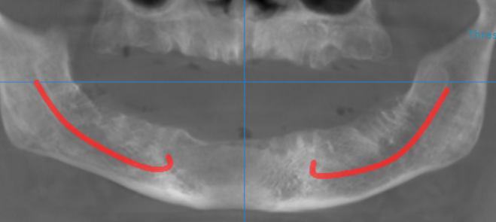

3-DIMENSIONAL VIEW
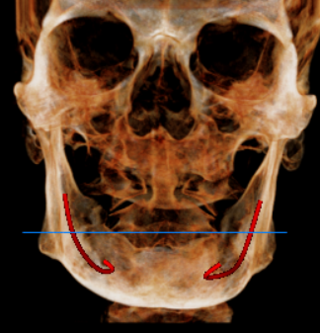

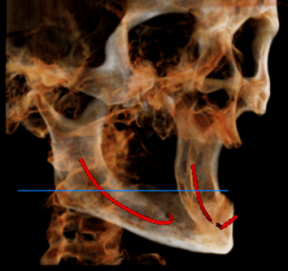
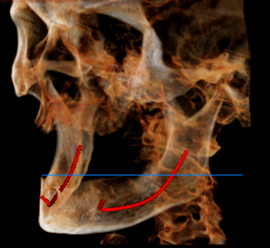

CROSS SECTIONAL VIEW

11 region | 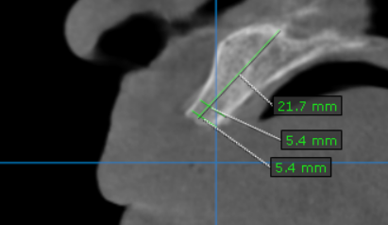
12 region | 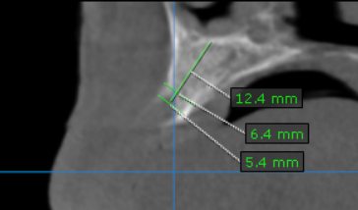
13 region | 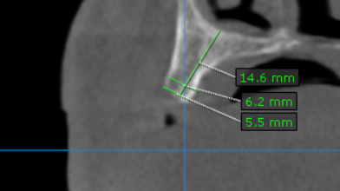
14 region | 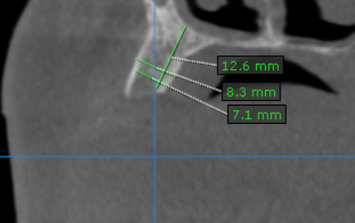
15 region | 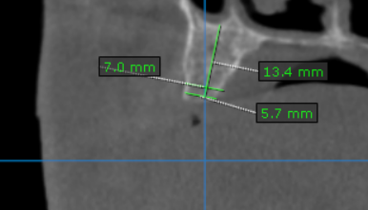
16 region | 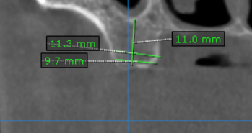
21 region | 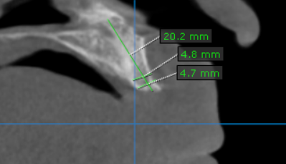
22 region | 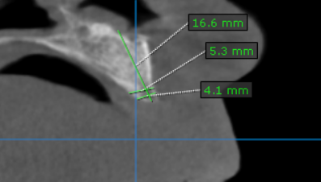
23 region | 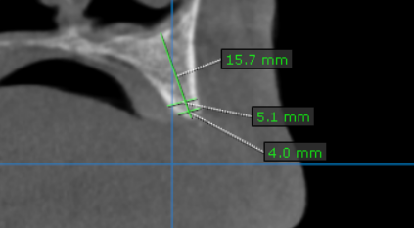
24 region | 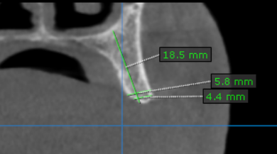
25 region | 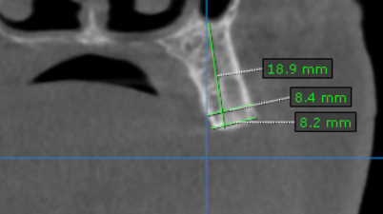
26 region | 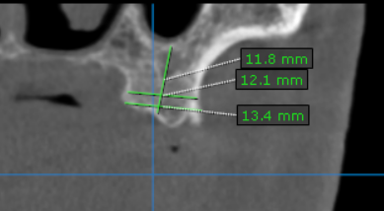
31 region | 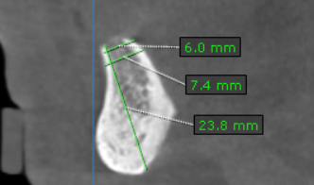
32 region | 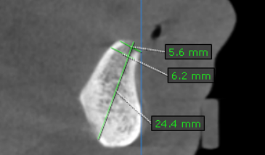
33 region | 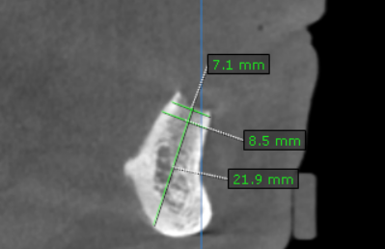
34 region | 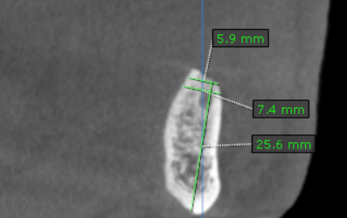
35 region | 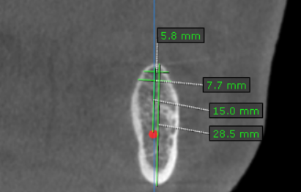
36 region | 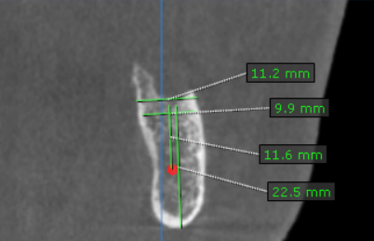
41 region | 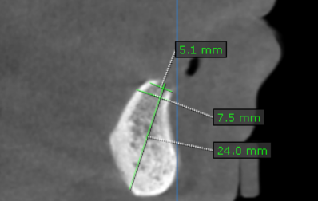
42 region | 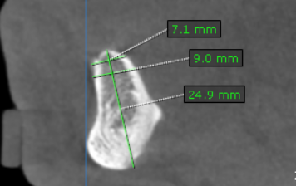
43 region | 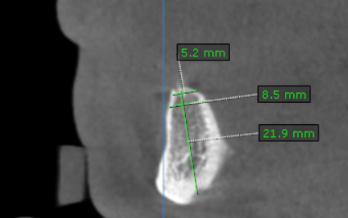
44 region | 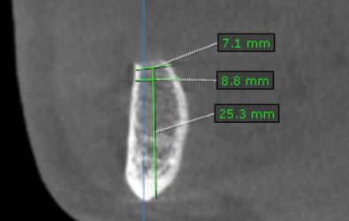
45 region | 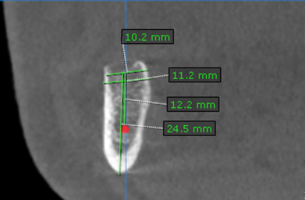
46 region | 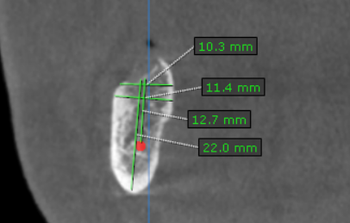

**** End of report ****

